
Commonwealth of Kentucky

Cabinet for Health and Family Services

Cabinet for Health and Family Services (CHFS) Information Technology (IT) Policy



020.303 Security Banner Policy

Version 2.9

July 9, 2025

Revision History

Date | Version | Description | Author
8/2/2002 | 1.0 | Effective Date | CHFS IT Policies Team Charter
7/09/2025 | 2.9 | Review Date | CHFS Policy Charter Team
7/09/2025 | 2.9 | Revision Date | CHFS Policy Charter Team
Sign-Off

Sign-off Level | Date | Name | Signature
Executive Director (or designee) | 7/9/2025 | Jennifer Harp | 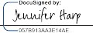
CHFS Chief Information Security Officer (or designee) | 7/7/2025 | Kelvin Brooks | 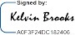

Table of Contents

- POLICY DEFINITIONS 4
- POLICY OVERVIEW 6
  - Purpose 6
  - Scope 6
  - Management Commitment 6
  - Coordination among Organizational Entities 6
  - Compliance 6
- ROLES AND RESPONSIBILITIES 6
  - Chief Information Security Officer (CISO) 6
  - Chief Privacy Officer (CPO) 7
  - Chief/ Deputy Chief Technology Officer (CTO) 7
  - Security/Privacy Lead 7
  - CHFS Contract, State, and Vendor Staff/Personnel 7
  - System Data Owner and System Data Administrators 7
- POLICY REQUIREMENTS 8
  - General Banner Information 8
  - Warning Banner Criteria 8
  - IRS Warning Banner Criteria 8
  - Banner Maintenance 8
  - Workstation Warning Banner Sample 8
- POLICY MAINTENANCE RESPONSIBILITY 9
- POLICY EXCEPTIONS 9
- POLICY REVIEW CYCLE 9
- POLICY REFERENCES 9

Policy Definitions
- Availability: Defined by the National Institute of Standards and Technology (NIST) 800-53 Revision 4 as ensuring timely and reliable access to and use of information.
- Confidential Data: Defined by the Commonwealth Office of Technology (COT) Standards Data of which the Commonwealth has a legal obligation to not disclose. This data requires the highest levels of restrictions, because of the risk or impact that will result from disclosure, modifications, breach, or destruction of that data. Examples include, but are not limited to, data not releasable under the Kentucky State law (Kentucky Revised Statute 61.878); Protected Health Information, Federal Tax Information, and Social Security and Credit Card Numbers.
- Confidentiality: Defined by NIST 800-53 Revision 4 as a preserving authorized restrictions on information access and disclosure, including means for protecting personal privacy and proprietary information.
- Contract Staff/Personnel: Defined by CHFS as an employee hired through a state approved (i.e., System Design/Development Services {SDS} Vendor Agreement/Company) vendor who has a master agreement with the state.
- Electronic Protected Health Information (ePHI): Defined by the Health Insurance Portability and Accountability Act of 1996 (HIPAA) Privacy Rule as individually identifiable health information, including demographic data, that relates to: the individual’s past, present or future physical or mental health or condition, the provision of health care to the individual, or the past, present, or future payment for the provision of health care to the individual, and that identifies the individual or for which there is a reasonable basis to believe can be used to identify the individual. Identifiable protected health information items include many common identifiers (e.g., name, address, birth date, Social Security Number). The Privacy Rule excludes from protected health information employment records that a covered entity maintains in its capacity as an employer and education and certain other records subject to, or defined in, the Family Educational Rights and Privacy Act, 20 U.S.C. §1232g.
- Federal Tax Information (FTI): Defined by Internal Revenue Service (IRS) Publication 1075 as federal tax returns and return information (and information derived from it) that is in the agency’s possession or control which is covered by the confidentiality protections of the Internal Revenue Code (IRC) and subject to the IRC 6103(p) (4) safeguarding requirements including IRS oversight. FTI is categorized as Sensitive but Unclassified information and may contain personally identifiable information (PII). FTI includes return or return information received directly from the IRS or obtained through an authorized secondary source, such as Social Security Administration (SSA), Federal Office of Child Support Enforcement (OCSE), Bureau of the Fiscal Service (BFS), or Centers for Medicare and Medicaid Services (CMS), or another entity acting on behalf of the IRS pursuant to an IRC 6103(p) (2) (B) Agreement. FTI includes any information created by the recipient that is derived from federal return or return information received from the IRS or obtained through a secondary source.
- Integrity: Defined by NIST 800-53 as the guarding against improper information modification or destruction and includes ensuring information non-repudiation and

authenticity.
- Personally Identifiable Information (PII): Defined by Kentucky Revised Statute (KRS) Chapter 61.931-934 and in accordance with NIST 800-53 Revision 4 as information which can be used to distinguish or trace the identity of an individual; person’s first name or first initial and last name, personal mark, or unique biometric or genetic print or image, in combination with one or more of the following data elements: account number, credit card number or debit card number that in combination with any required security code, access code or password would permit access to an account; social security number, taxpayer ID number, driver's license number, state ID number, passport number or other ID number issued by the United States government, or individually identifiable health information, except for education records covered by The Family Educational Rights and Privacy Act of 1974 (FERPA). In addition, HIPAA identifies an individual’s full name, date of birth, street or email address, biometric data, and other common identifiers as direct PII, not requiring a combined additional field of information.
- Sensitive Data: Defined by COT standards as data that is not legally protected but should not be considered public information and only be disclosed under limited circumstances. Only authorized users should be granted access to sensitive data. Examples include: all information identifiable to an individual including staff, employees, and contractors but not limited to dates of birth, driver’s license numbers, employee ID numbers, license plate numbers, and compensation information. The Commonwealth’s proprietary information including but not limited to intellectual property, financial data and more.
- State Staff/Personnel: Defined by CHFS as an employee hired directly through the state within the CHFS with final approval and appointment by the Kentucky Personnel Cabinet.
- Vendor Staff/Personnel: Defined by CHFS as an employee contracted through an approved Master Business Associate Agreement, or other formal agreement, to provide temporary work for CHFS.

Policy Overview

Purpose
The Cabinet for Health and Family Services (CHFS) must establish a comprehensive level of security controls through a Security Banner Policy. This document establishes the agency’s Security Banner, which helps manage risks and provides guidelines for security best practices regarding security banner notification content.

Scope
The scope of this policy applies to all internal CHFS state, contract, and vendor staff/personnel, temporary personnel, third party providers under contract with a CHFS agency, and other entities that interact with CHFS information related resources. This policy covers the applicable computer hardware, software, application, configuration, business data, and data communication systems. Pertains to applications containing IRS FTI data.

Management Commitment
Division Directors, the CHFS Chief Technical Officer (CTO), Chief Information Security Officer (CISO), and IT Executive Management have reviewed and approved this policy. Senior Management supports the objective put into place by this policy. Violations of not abiding by this policy may result in disciplinary action, which may include suspension, restriction of access, or more severe penalties up to and including termination of employment. CHFS shall report illegal activities or theft of CHFS property (physical or intellectual) to the appropriate authorities.

Coordination among Organizational Entities
Coordination within CHFS organizations and/or agencies that access applications, systems, and facilities. All organizational entities that interact with CHFS are subject to follow the requirements outlined within this policy.

Compliance
As the official guidance domain for this policy, CHFS agencies abide by the security and privacy requirements established in applicable state laws and regulations as well as federal guidelines outlined in the NIST. Additionally, applicable agencies follow security and privacy frameworks outlined within CMS, the IRS, and SSA.

Roles and Responsibilities

Chief Information Security Officer (CISO)
An individual responsible for providing guidance and direction in assessment, planning, and implementation of all security standards, practices, and commitments required.
The CHFS CISO is the designated official to oversee the development, documentation, and dissemination of the CHFS policies and procedures. This individual is responsible for adherence to this policy.

Chief Privacy Officer (CPO)
The designated official responsible to oversee activities related to the development, documentation implementation, dissemination, maintenance of, and adherence to the Cabinet's and Commonwealth's information privacy and confidentiality policies and procedures in compliance with federal and state laws. An individual responsible for overseeing activities related to the development, implementation, maintenance of, and adherence to the Cabinet's and Commonwealth's information privacy and confidentiality policies and procedures in compliance with federal and state laws. This individual will conduct Health Insurance Portability and Accountability Act (HIPAA) risk assessments through coordination with the Information Security Agency Representative, the CISO, or CHFS Information Security (IS) Team, and other CHFS agencies, and will ensure compliance with HIPAA notification and reporting requirements in the event of an identified breach. This position is responsible for adherence to this policy.

Chief/ Deputy Chief Technology Officer (CTO)
This individual makes decisions related to a company's technology. This includes the integration and deployment of new technology, systems management and the overseeing of technical operations personnel. The CTO also works with outside vendors to ensure they meet customer service expectations. This individual is responsible for adherence to this document.

Security/Privacy Lead
Individual(s) designated by the division leadership to coordinate privacy and/or security issues and incidents with all appropriate staff/personnel. This individual(s) is responsible for providing privacy and security guidance and direction for the protection of PCI, (PII), ePHI, FTI and other financially sensitive information to all CHFS staff/personnel. This role, along with the CHFS IS Team, is responsible for adherence to this policy.

CHFS Contract, State, and Vendor Staff/Personnel
All CHFS contract, state, and vendor staff/personnel must adhere to this policy. All staff/personnel must comply with referenced documents, found in section 8 Policy References below that pertain to the agency’s applications, application servers, appliances, operating systems, web servers, network components, and database (server or components) that reside on CHFS information system(s).

System Data Owner and System Data Administrators
Management/lead who works with the application’s development team to document components that are not included in the base server build and ensures that functionality and backups are conducted in accordance with business needs. This individual(s) is also responsible for working with personnel within the enterprise, agency, application, technical, and business areas, for providing full recovery of all application functionality, as well as meeting federal and state regulations for disaster recovery situations.

Policy Requirements

General Banner Information
CHFS complies with and adheres to COT ENT-201: Enterprise Security Controls and Best Practices as well as all applicable governing agencies regarding context in warning banners.

Warning Banner Criteria
Screens must include a special security notice that states the following points:
    - The system may only be accessed by authorized users.
    - Users who access the system beyond the warning page represent that they are authorized to do so.
    - Unauthorized system usage or abuse is subject to criminal prosecution.
    - System usage may be monitored and logged.

IRS Warning Banner Criteria
Access to any IRS FTI, shall contain a warning banner with elements regulated in IRS Publication 1075 Exhibit 8.
The following elements must be contained within the warning banner:
    - The system contains U.S. Government information.
    - User actions are monitored and audited.
    - Unauthorized use of the system is prohibited.
    - Unauthorized use of the system is subject to criminal and civil sanctions.
Users logging onto CHFS workstations through Virtual Private Network (VPN) are subject to accept/agree to the IRS Publication 1075 Exhibit 8 warning banner criteria as stated above, before access is granted.

Banner Maintenance
It is the responsibility of COT to establish and maintain all security banners for CHFS equipment. CHFS maintains banners for business applications.

Workstation Warning Banner Sample
The below text shall be displayed on all CHFS workstations, at logon, to inform staff that such monitoring may occur without warning.

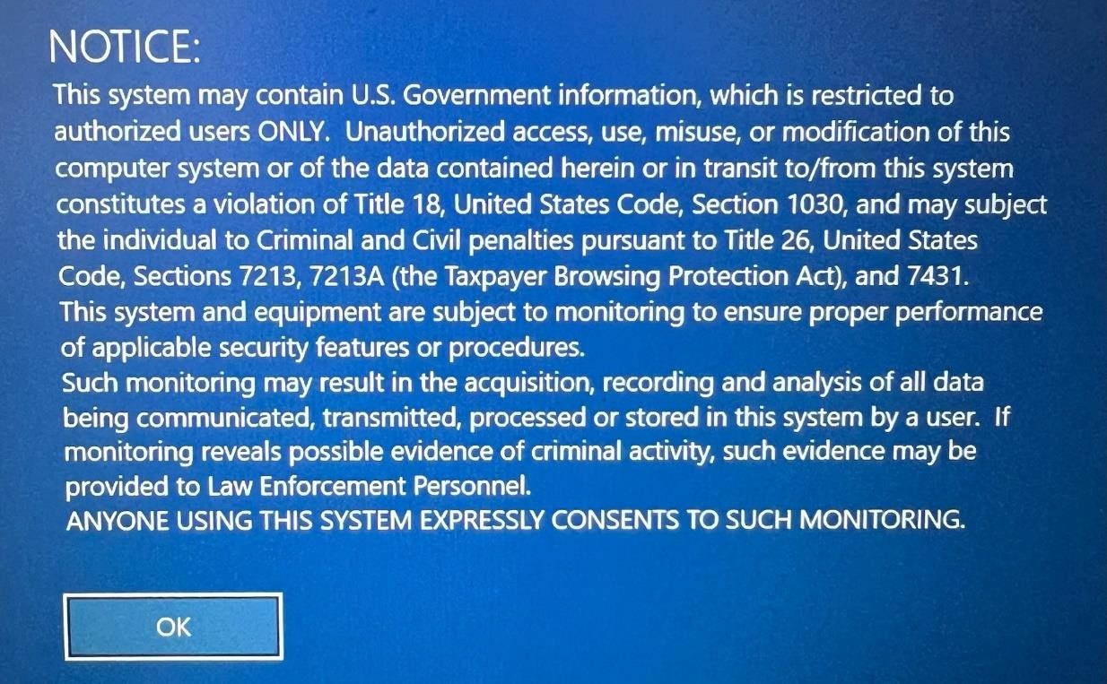

Policy Maintenance Responsibility
The IS Team is responsible for the maintenance of this policy and ensuring there is alignment with NIST SP 800-53 Rev 5. Further policy review and updates are evaluated and coordinated through the Policy Charter Team including representatives from CHFS agencies including areas responsible for security, risk management, privacy, legal, and IT services.

Policy Exceptions
Any exceptions to this policy must follow the guidance established in CHFS Policy: 070.203- Security Exceptions and Exemptions to CHFS Policies and Security Control Policy.

Policy Review Cycle
This policy is reviewed at least once annually and revised on an as needed basis.

Policy References
- Centers for Medicare and Medicaid Services (CMS) Acceptable Risk Controls for Affordable Care Act (ACA), Medicaid, and Partner Entities (ARC-AMPE)
- CHFS Policy: 070.203- Security Exceptions and Exemptions to CHFS Policies and Security Control Policy
- ENT-201: Enterprise Security Controls and Best Practices
- Internal Revenue Services (IRS) Publication 1075
- Kentucky Revised Statute (KRS) Chapter 61.878 Certain public records exempted from inspection except on order of court – Restriction of state employees to inspect personnel files prohibited.
- National Institute of Standards and Technology (NIST) Special Publication 800-53 Revision 5, Security and Privacy Controls for Federal Information Systems and Organizations
- Social Security Administration (SSA) Security Information

